**Neha Malhotra**  **R.L. Institute M: 9416974837**

**Max Time : 1 hr** **Class = 12th Biology Test**  **Max Marks : 25**

**MOLECULAR BASIS OF INHERITANCE**

**[DNA structure , Search of Genetic Material]**

1. Multiple choice questions : [ 1 X 5 = 5]
2. The figure given below has labellings (i) , (ii) , (iii) which two labellings in the given figure are of a nucleosome? Select correct option .

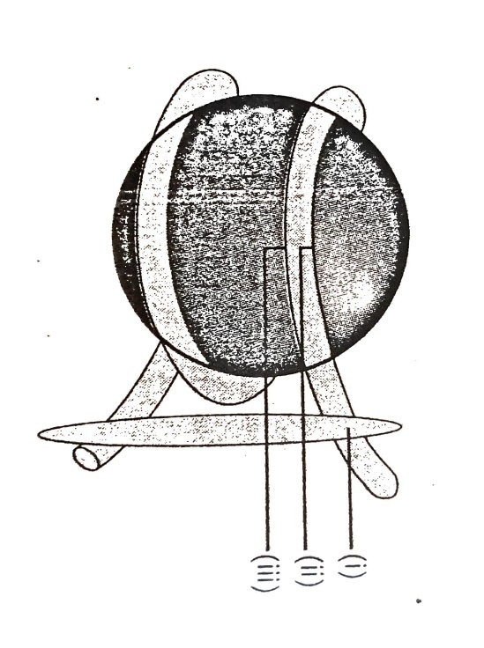

|  |  |
| --- | --- |
| a) (i) H1 histone (ii) DNA | b) (i) DNA (ii) Histone octamer |
| c) (i) DNA (ii) H1 histone | d) (i) Histone octamer (ii) DNA |

1. Which of the following amino acids residues will constitute the histone core?

|  |  |
| --- | --- |
| a) Lysine and Arginine | b) Asparagine and Arginine |
| c) Glutamine and Lysine | d) Asparagine and Glutamine |

1. A stretch of euchromatin has 300 nucleosomes. How many bp will there be in the stretch and what would be the length of the typical euchromatin?

|  |  |
| --- | --- |
| a) 60,000 bp and 20,300 x 10 – 9 nm | b) 60,000 bp and 20,400 x 10 – 9 nm |
| c) 30,000 bp and 20,400 x 10 – 9 nm | d) 40,000 bp and 20,300 x 10 – 9 nm |

1. The net electric charge on DNA and histones is :

|  |  |
| --- | --- |
| a) both positive | b) both negative |
| c) Positive and negative respectively | d) zero |

1. The average guanine content in yest is found to be 18 %. Which of the following represents the nitrogenous base content percentages correctly from the above data.

|  |  |
| --- | --- |
| a) A : 18 % ; T : 18 % ; C : 36 % | b) A : 36 % ; T : 32 % ; C : 32 % |
| c) A : 32 % ; T : 32 % ; C : 18 % | d) A : 18 % ; T : 18 % ; C : 18 % |

1. What is the reason behind uniform width of DNA? [ 1 ]
2. Name the transcriptionally active region of chromatin in a nucleus. [ 1 ]
3. Calculate the length of the DNA of bacteriophage lambda that has 48502 base pairs. [ 1 ]
4. Write the characteristics of genetic material. [ 1 ]
5. Group the following as Nitrogenous base and Nucleosides: [ 1 ]

Adenine , Cytidine , Thymine , Guanosine , Uracil and Cytosine.

1. Define Chargaff’s rule. [ 1 ]
2. Describe the structure of nucleosomes. [ 2 ]
3. A DNA segment has total 1500 nucleotides, out of which 410 are adenine containing nucleotides. How many pyrimidines bases this DNA segment possess? [ 2 ]
4. Mention the carbon positions to which the nitrogeneous base and the phosphate molecule are respectively linked in the nucleotide, also write the name the bond (linkage) formed between them.

[ 2 ]

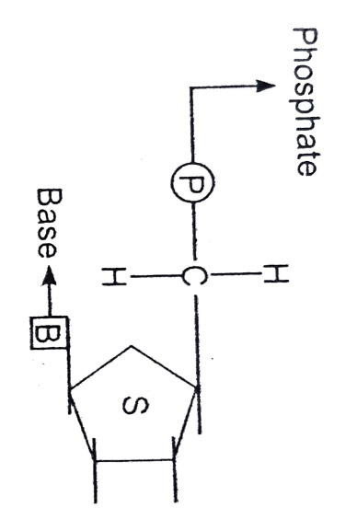

1. Explain two factors responsible for conferring the stability of double helix structure of DNA. [ 2 ]
2. Describe the experiment with Streptococcus Pneumonia that demonstrated the existence of some transforming principle. [ 3 ]
3. List the salient feature of double helix structure and draw the diagrammatic sketch of a portion of DNA to support your answer. [ 3 ]